

As part of our ‘Sow and Grow’ topic we will have some very special baby visitors to our classroom. Children’s baby photos are appreciated so we can make a ‘who’s who’ baby & child guessing game display.
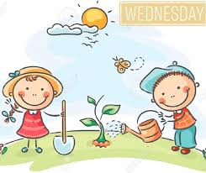
Dates for your diary:


World Book Day: Thursday 7th March
Red Nose Day: Friday 15th March
Parent’s Maths workshop: Thursday 21st March
Mums & Auntys Day: Wednesday 27th March
Parent’s Evening: Wed 27th & Thur 28th
& Monday 1st April
Easter Bonnet: Tuesday 2nd April

***Attention Mums and Aunties Day***
You are invited to come and spend some time with us on Wednesday 27th March

AM Nursery: 10:30-11:30
PM Nursery and Reception: 1.45pm until 2:45pm
“All Saints Foundation Unit”

Our topic for this half term is
“Sow and Grow” 

“Welcome Back”
to everyone after our half term break. We hope you all had a lovely time.


We value feedback from parents/carers. Please let staff have any comments or suggestions you may have about how we can further improve our practice in the Foundation stage.

If you would prefer to write your comments or feedback on a sheet please ask a member of staff for a parent’s voice sheet.

“Parent’s Voice”

Please ensure that your child brings his/her water bottle to nursery every day.
Please only use unflavoured, still water!

“Thank you” to everyone for all your support last term. We are really looking forward to working with you again this term!


Fridays:
Nursery Library
Please make sure you remember to bring your library books in every Friday so that you can change them.

Easter Bonnet Parade

Prizes for the most creative Easter Bonnets made by the children.


