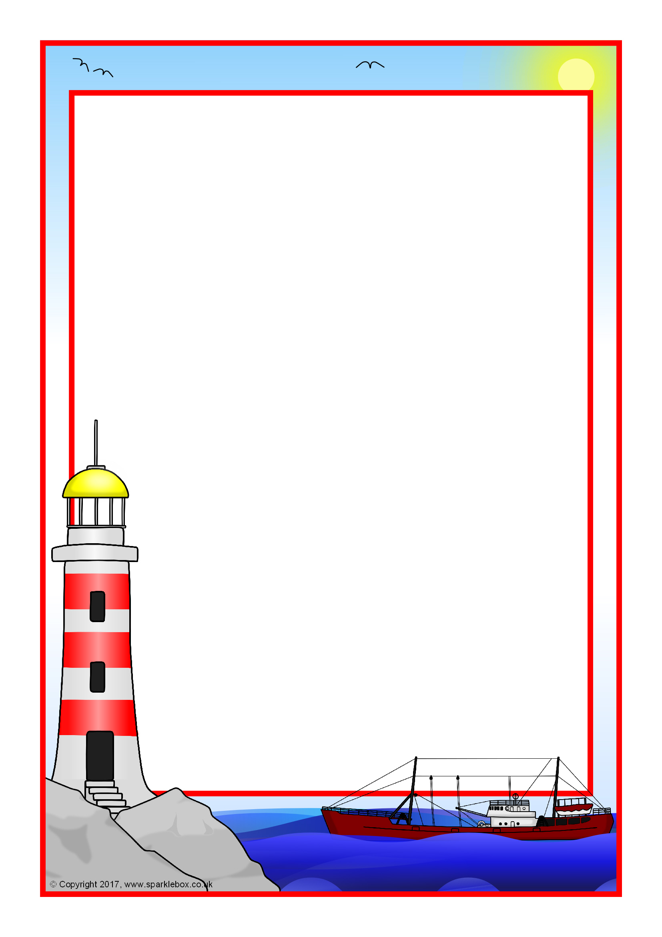

In **Science,** we are looking at ‘Our Changing World’. The children will explore the requirements for plants to grow and continue to explore the part flowers play in the life cycle of a plant.

In **Computing** this term, we are ‘Opinion Pollsters’. Children will be creating their own poll, gathering feedback through the internet and then creating their own graphs or spreadsheets to analyse the data.

P.E will continue to be on a **Monday and Friday**. Please ensure your child has the correct P.E. kit and pumps in school at the beginning of each term so that it is always available.

Your child will continue to bring home their home reading book and will be entered into a whole school prize raffle if they have read 5 times a week. You can help your child further if you ask them questions about the story or ask them to predict what is going to happen and why. This all helps with their understanding of what they have read. Children will continue to bring home weekly **spellings on a Monday and weekly maths homework on a Friday.**

If you have any worries or concerns please feel free to speak to us.

**Miss Taylor and Mrs Allat**

**Location, Location!**

Welcome back to the final half of the Summer Term! This term will be extremely busy involving lots of exciting activities including two trips and a transition into Year 4!

Our topic this term is Location, Location. In this topic the children will be studying a locality from elsewhere in the UK, which will be the seaside town of Fleetwood! Children will be locating Fleetwood on a map and comparing and contrasting it with Rochdale. They will study the different physical and human features of both towns and will learn about the history of Fleetwood. This topic also incorporates different creative activities such as sketch maps and collages. The children will then gain first hand experience of a seaside town when we visit Fleetwood for our field trip in July.

In **Literacy**, we are studying ‘Stories with familiar settings’. The children will focus on listening to stories set in familiar surroundings and describing a setting using what they can see, hear, smell etc. Towards the end of the term the children will begin to look at ‘Information texts’ and will write their own report in the style of a travel guide on Fleetwood.

In **Numeracy**, children will continue to develop their written column methods for addition and subtraction using 3-digit numbers. We will be learning to read the time to the nearest minute and will develop further methods for multiplication and division.