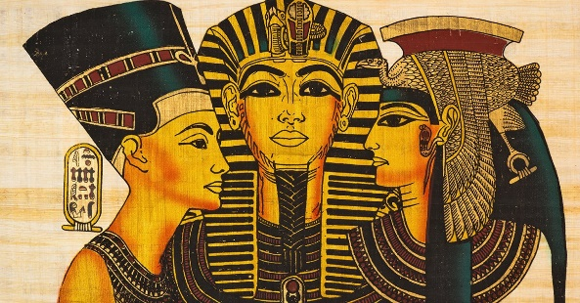

Task 2:

Create a menu for a rich ancient Egyptian banquet.

Task 3:

Find out why and how the Egyptians mummified their dead?

Task 5 (optional)

Make Tutankhamen’s death mask.

Task 4:

Research where most of the Ancient Egyptians lived and why they lived there.

Task 1:

Record ten facts about present day and ancient Egypt.

**Please the complete the task 1 -4 and remember to hand your work in on the 4th December 2020. Task 5 is optional and you may choose to take a photograph of it to include in your homework book.**

**Walk like an Egyptian**